# Using the Viterbi Algorithm for Part-Of-Speech Tagging

The problem to solve is to find the most likely sequence of parts of speech (Noun, Modal, or Verb) to have generated a given utterance (“Mary Can See Spot”. Provided we have all the necessary parameters of a Hidden Markov Model, we can use the Viterbi algorithm to solve this problem. The following two tables give the transition model and the emission model (respectively) for this HMM.

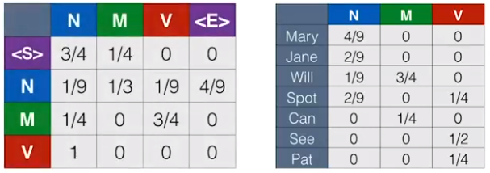

1. (b)

Transition model: for example, the probability of Emission model: for example, the probability

transitioning from <S> to N is ¾. of “Mary” given N is 4/9.

Below we see part of the trellis diagram for an HMM for this problem. The edges are not (yet) shown.

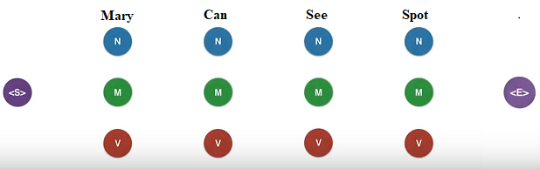

Apply the Viterbi algorithm to find the most probable path through the network, given the emission sequence “Mary Can See Spot.”

S->N->M->V->N->E